|  |  |
| --- | --- |
| **COURSEWORK ASSIGNMENT** | |
| **Module Title: Team Software Project** | **Module Code: 4WCM2010** |
| **Assignment Title: Interim Project Report** | **Individual Assignment** |
| **Tutor**: Dr. Barry Ip | **Internal Moderator**: Dr. Gabriella Lakatos |

|  |  |
| --- | --- |
| Student ID Number **ONLY**: | Year Code: |
| 23016710 | 2023/2024 |

|  |  |
| --- | --- |
| Marks Awarded %: | Marks Awarded after Lateness Penalty applied %: |
| Penalties for Late Submissions   * Late submission of any item of coursework for each day or part thereof (or for hard copy submission only, working day or part thereof) for up to five days after the published deadline, coursework relating to modules at Levels 0, 4, 5, 6 submitted late (including deferred coursework, but with the exception of referred coursework), will have the numeric grade reduced by 10 grade points until or unless the numeric grade reaches or is 40. Where the numeric grade awarded for the assessment is less than 40, no lateness penalty will be applied. * Late submission of referred coursework will automatically be awarded a grade of zero (0). * Coursework (including deferred coursework) submitted later than five days (five working days in the case of hard copy submission) after the published deadline will be awarded a grade of zero (0). * Where genuine serious adverse circumstances apply, you may apply for an extension to the hand-in date, provided the extension is requested a reasonable period in advance of the deadline. | |
| Please refer to your student handbook for details about the grading schemes used by the School when assessing your work. Guidance on assessment will also be given in the Module Guide. | |
| Guidance on avoiding academic assessment offences such as plagiarism and collusion is given at this URL: <http://www.studynet.herts.ac.uk/ptl/common/LIS.nsf/lis/citing_menu> | |

**Interim Project Report**

**Project Title: Electrify My Car**

**Purpose of the project:** This report outlines the current status of our team project, which presents the details of the progress we have made up to this point. After a team discussion via “whatsapp” group we decided to make an application on Electric Cars. Everbody voted on poll for the topic they wanted to work on so do I, I voted for an EV application because I am very keen interested in Cars.

Following are the aims of our team project and Which I think should be highlighted the

most among all:

1. To create a user freiendly application which will be easy to understand.
2. Create an app with intuitive navigation and an appealing design to attract users, even those not interested in car purchases, encouraging them to explore the website. The application should be visually attractive, easy to use, and designed to captivate users' attention, regardless of their initial interest in cars.
3. To display enough information of an electric car that makes easier for a person to select a car which suits his demands and needs.
4. To display the numerous benefits of an Electric Car that will help in persuading a person to buy an Electric Car.

The members of the team are and weekly report:

|  |  |  |  |
| --- | --- | --- | --- |
| **Member** | **Task-Week 1** | **Task Week-2** | **Task Week-3** |
| Oluwafikayomi Adeogun ( Team leader, Application Developer) | After voting poll for project and leader, He was nominated as a group leader and Electrify My Car was decided as a topic for our project.  Researched on Optimal Programming Language and Database:Investigated the best programming language, suitable databases, and public viewing options for the application. Justified choices with industry trends, benchmarks, or expert opinions.  Documented the sources without relying solely on ChatGPT for referencing. | Worked on own on the coding aspect (get the application and external platform up and running, start coding with our own template (e.g. discussing what to add and then adding the info already given by Esha, using any color or font, working out the API’s) before then integrating the design gotten from Abdullah and Anmol. | Working on coding, and trying to complete soon. |
| Abdullah Rahmani(Assistant Team leader and UI/UX Designer) | Research and Design Visual Elements:Investigated and decided on visual components such as icons, logos, colours, and fonts for the application. Deciding the layout, the structure, where features, information, sections will be placed etc.Use design tools like Paint, Autodesk, Google Drawings, or Adobe to visually represent the application's layout.Provide references for design choices, avoiding reliance on ChatGPT for this documentation. | Continue to work with Anmol on the design. (images, logo, what color, font, to use, features/sections, icons/buttons etc.)    <https://99designs.com/blog/web-digital/how-to-design-an-app/#options> | Continued 2nd week task. |
| Syeda Anmol(UI/UX Designer) | Research Essential Features for the Application:Explore features, sections crucial for user engagement, that should be on the app like a map displaying nearby charging points, user reviews, charging cost calculators, etc.Document the sources of research and references for each identified feature. Avoid direct reliance on ChatGPT for referencing; use authoritative sources. | Continue to work with Abdullah on the design(images, logo, color, font, to use, features/sections, icons/buttons etc.)  <https://99designs.com/blog/web-digital/how-to-design-an-app/#options> | Continued 2nd week task. |
| Esha Shahid(Researcher, Tester) | Conduct Comprehensive Background Research on Electric Cars:Investigate the origins(history), manufacturers, production processes, timelines, costs, types of electric cars and charging mechanisms of electric cars etc.Document sources, avoiding ChatGPT, and provide clear references for all gathered information.  *Finalized my research using Word. | Continue to work on the gathering, structuring of the information and objectives. And discussing and providing the answers for the questions been asked by group members. | I am working on fonts for suggesting them, App name and the information that is suitable and important to mention in project. |

**Background/Literature Review:** Our team leader assigned certain tasks to all of group members in which I was asked to study the background of Electric Cars. I was told to look into background thoroughly because the matter I collected would indicate what type of application to make,which is a very important part. First of all I studied the origin of Electric Cars in which I got to know that a American inventer William Morrison first presents the practical of EV in about 1890 also many people says that the first small scale of electric cars progress were made in 1828-1832.The first electric vehicle was displayed at industry conference in 1835. I found all of this through google search engine and google scholar engine.While searching I got to know which car companies are owning the people attraction in automobile industry e.g; Tesla, BYD, Ford, Chevy Bolt etc. I also searched, what are the demands of people for buying an electric cars and what are the difficulty facing by people while going through the online websites due to which eventualy ended up not buying EV or online apps are of no use. Then I started visiting multiple car companies websites e.g Tesla, BMW, Audi, Hyundai, BYD etc, just to know what a website should be like,I got to know there isn’t enough information about the Electric car, its charging ports, prices and charging costs etc. I also studied about what are we supposed to do to make our website one of the most visited and I ended up collecting the several advantages of Electric car then comparing them with conventional engine cars. I downloaded some apps like Pak Wheels for idea of format, color logos etc.

**Completed work to date:** As I was assigned to research I did all of the matter research and send it over to my group. I go through all of the decided matter regarding the themes and platform like using figma and balsamiq in which I also thought figma better than balsamiq. So, voted for figma. While searching matter from websites I got to know that the fonts and the themes matters a lot and personally, also I have seen many people attracting towards dark theme so I agreed-upon that the theme would be Dark background complemented by suitable fonts and colors which suits our motives and aims for an Electric Car app. The app will contain 5 main pages each with corresponding sub-page: simple start, a tab page, Car details in which prices/ comparsion page, cost of charging and charging points. Done designing of our application on Wireframe. The Prototype link given below of figma is the draft I made for suggestion and for the app name suggestions I gave “ElectroRide”. Also the link below of figma under the heading of “Prototype decided” is the prototype we have agreed to use. I have made a Trello board for my progress in which I have mentioned; what I have done, what I am doing and what work is remaining to do.

**Work remaining:**  Following is the work remaining, in which we all are working together:

1. Completing remaining pages, fonts and colors
2. Coding part
3. Prototype remaining
4. Testing of the application
5. Recording feedbacks that can help in improvement
6. Completing Final Report

Our group leader made an excel sheet initially to record what we have done and what are we upto. And Our group leader also made an gantt chart. My task that is remaining is to:

* Test the application on various devices, both IOS and Android, give feedback and evaluation of testing.
* Come up with different scenarios of testing such as “what happens if the user’s internet goes off as he/she is viewing the application”, “what if the user accidentally clicks on the wrong button, how easy will it be for them to go back to where they were before.”

**References:**

**For benefits of buying an electric car:**

[**http://www.americanscholarspress.us/journals/IMR/pdf/IMR-2- 2022/IMR2022FAllspecil-art10.pdf**](http://www.americanscholarspress.us/journals/IMR/pdf/IMR-2-%20%20%20%20%202022/IMR2022FAllspecil-art10.pdf)

**Benefits by : Peugeot company:**

[**https://www.peugeot.co.uk/electric-and- hybrid/advantages.html#:~:text=Choosing%20an%20electric%20PEUGEOT %20not,example%20is%20between%204%2D6p**](https://www.peugeot.co.uk/electric-and-%20%20%20%20%20%20%20%20%20%20%20%20%20%20%20%20%20%20%20%20%20%20%20%20hybrid/advantages.html#:~:text=Choosing%20an%20electric%20PEUGEOT %20not,example%20is%20between%204%2D6p)**.**

**For car personal info:**

<https://energydigital.com/top10/top-10-electric-vehicle-companies>

<https://www.tesla.com/>

<https://www.byd.com/en>

<https://www.mercedes-benz.com/en/>

<https://www.hyundai.com/worldwide/en>

<https://www.audi.com/>

**Car Application for ideas:**

1. PakWheels
2. OLX.pk
3. Gari.pk

**Websites:**

**Used by Abdullah and Anmol for designing purpose:**

[**https://99designs.com/blog/web-digital/how-to-design-an-app/#options**](https://99designs.com/blog/web-digital/how-to-design-an-app/#options)

**For the history of Electric car :**

[**https://blog.evbox.com/electric-cars-history**](https://blog.evbox.com/electric-cars-history)

**Trello Board:**

<https://trello.com/invite/b/Q8ud2Dcp/ATTI4ad3274168a88655b1e5b997757de8e6DEDFD80A/my-trello-board>

**Excel Sheet made for recording progress:**

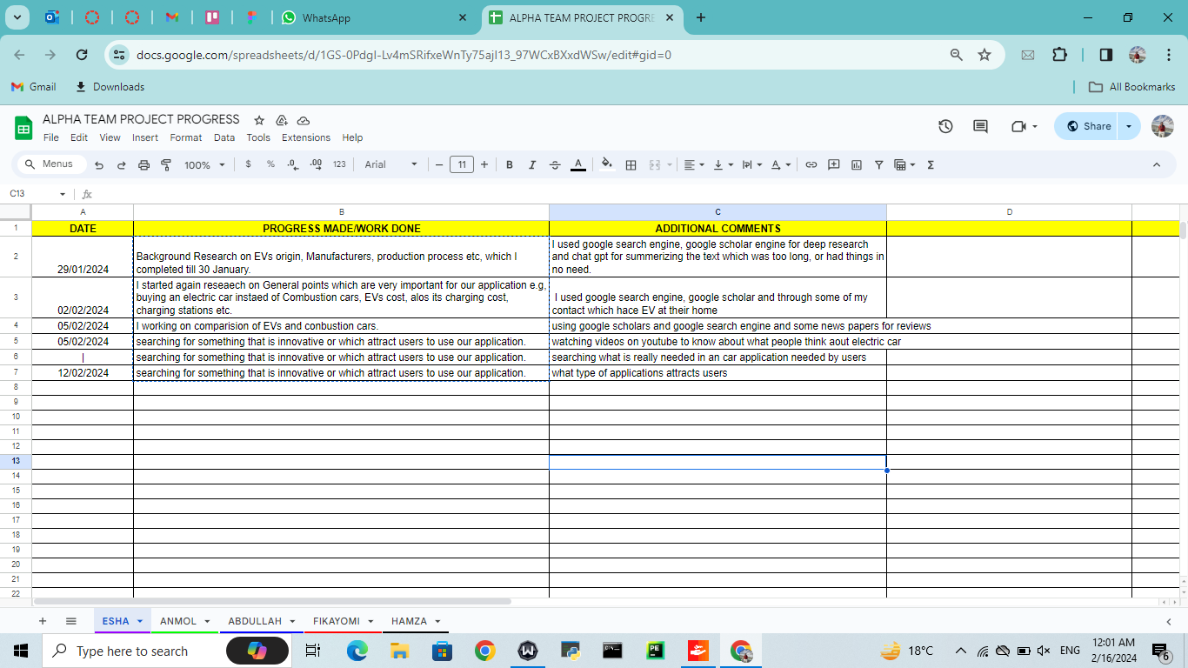

**Figma:**

My suggestion:

[**https://www.figma.com/file/gAZMi375pn6RoApD3ziixR/Untitled?type=design&node-id=0%3A1&mode=design&t=HHrcOzspYtPdO0Wi-1**](https://www.figma.com/file/gAZMi375pn6RoApD3ziixR/Untitled?type=design&node-id=0%3A1&mode=design&t=HHrcOzspYtPdO0Wi-1)

**The prototype decided:**

[**https://www.figma.com/file/eM7xDGbksKmLw8SPOpPtv5/Alpha-Design-Project?type=design&node-id=0%3A1&mode=design&t=YpumGFM93ajL4pDN-1**](https://www.figma.com/file/eM7xDGbksKmLw8SPOpPtv5/Alpha-Design-Project?type=design&node-id=0%3A1&mode=design&t=YpumGFM93ajL4pDN-1)

**Appendix:**

Agendas of meeting:

Mostly about the information important for app, About what software to use for designing and coding. Also what is the task for the week and what are the deadlines for the tasks assigned.

Minutes of Meeting:

Mostly we had conversations on our team group.

Individual and Group Gantt Charts:

Here is the progress report on Gantt chart.

